Guettaway
A Diamond Club production

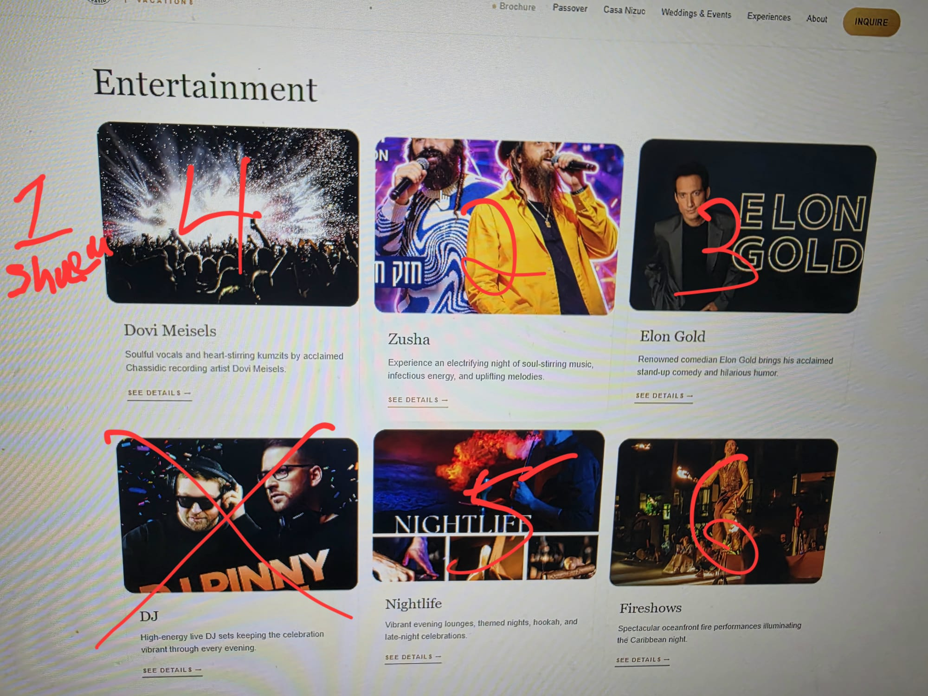

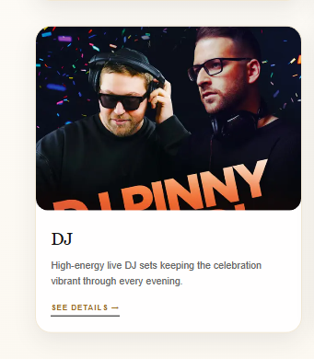
Remove

Add
### SHULEM LEMMER – LIVE IN CONCERT

Experience an extraordinary evening with *internationally acclaimed vocalist Shulem Lemmer*, whose magnificent voice and remarkable vocal range have captivated audiences around the world.

Renowned for his breathtaking performances, soulful melodies, and powerful stage presence, Shulem brings a spectacular blend of timeless classics, beloved favorites, and uplifting music to the stage.

From deeply moving ballads to exhilarating musical masterpieces, prepare for an unforgettable concert filled with passion, elegance, and extraordinary talent.

*One extraordinary voice. A world-class performance. An unforgettable night of music!*

See pic
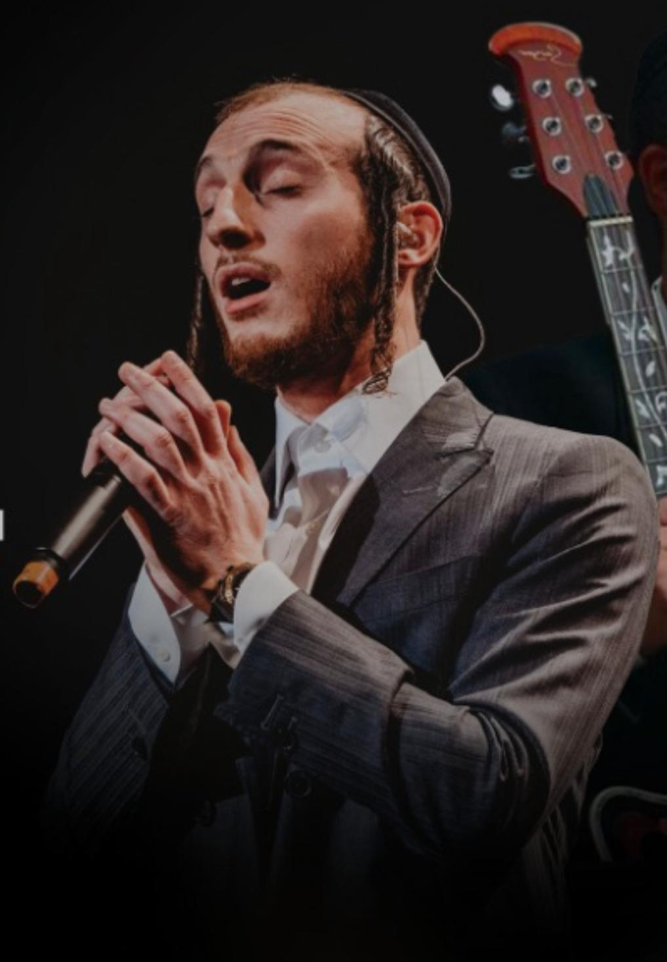

dining in the Park Hyatt is different than the world of

This is only for the park hyatt

### NUTRE Kitchen
*Breakfast & Dairy Dining*

Start your morning with an extensive breakfast featuring live cooking stations and freshly prepared favorites. Open for lunch with a complete dairy menu, including a dedicated pizza station, with both beachfront and indoor dining available.

### IKAL Beach Grill
*Beachfront BBQ & Casual Dining*

Enjoy an all-day beachfront barbecue featuring freshly grilled favorites and a variety of specialties, served directly on the beach or in the comfort of our indoor dining area.

### Bruma Steakhouse
*Signature Steakhouse Dining*

A sophisticated specialty steakhouse offering exceptional cuts, expertly prepared dishes, and an elevated dinner experience during Chol Hamoed.

### Patisserie Market & Café
*All-Day Coffee & Desserts*

Your all-day destination for freshly brewed specialty coffees, an irresistible selection of premium kosher-for-Passover desserts, pastries, and sweet treats.

### The Living Room
*24-Hour Lounge & Relaxation*

Open around the clock, The Living Room offers a welcoming, fully air-conditioned retreat to unwind, enjoy a drink, read a book, or simply relax in a comfortable and peaceful setting.

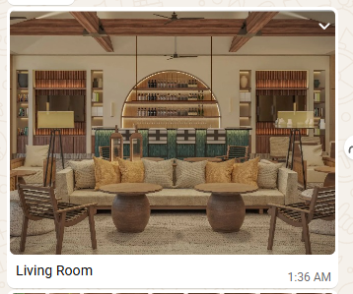

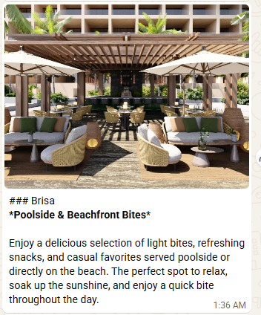

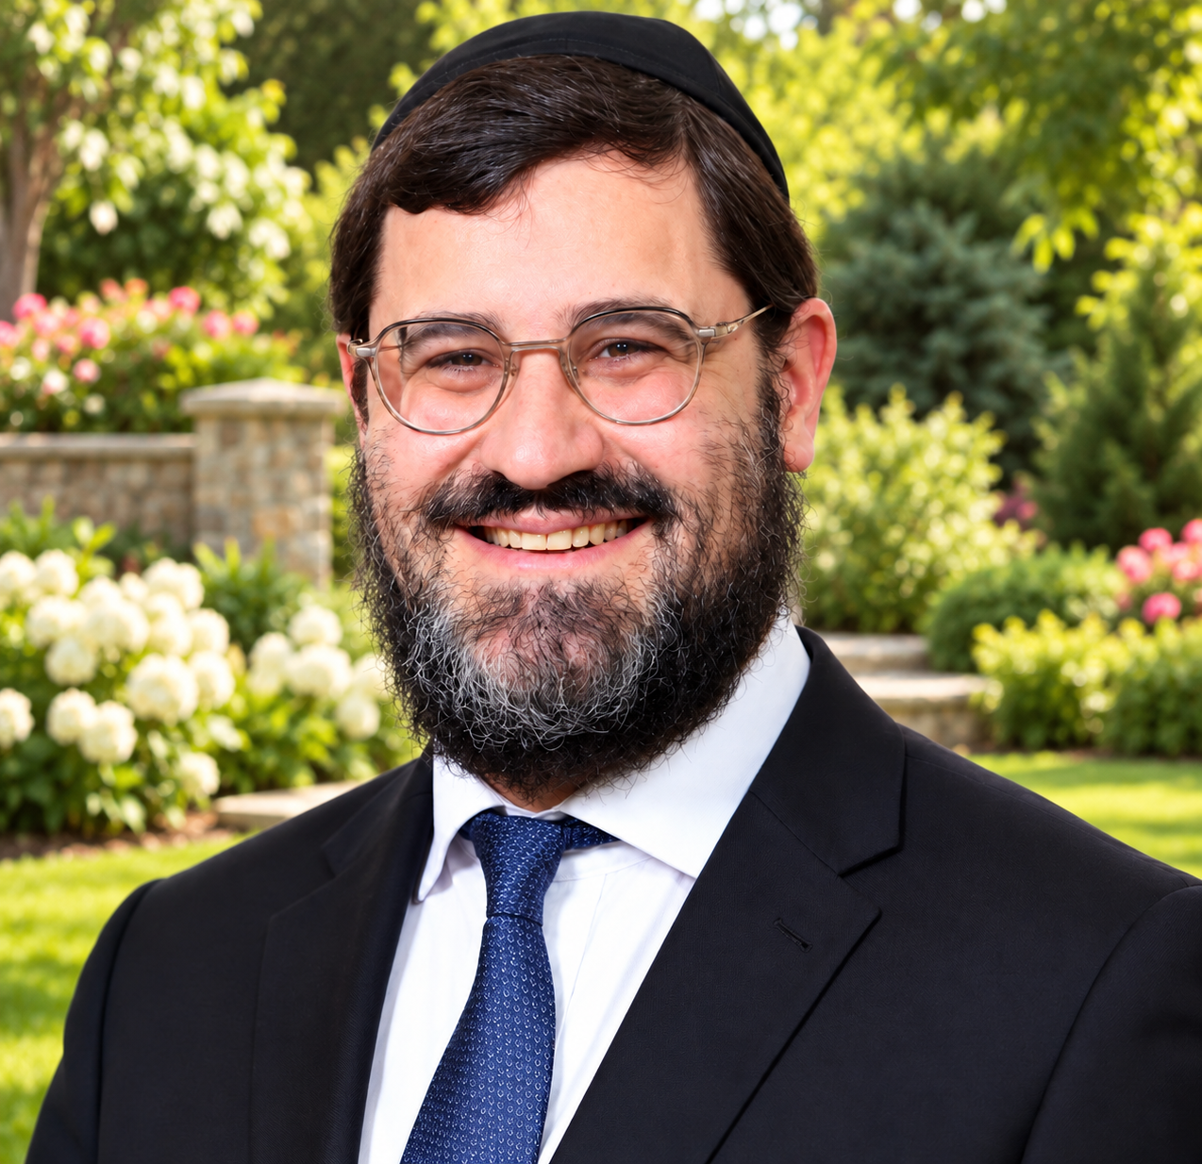

This is Rabbi Avi Wiesenfeld

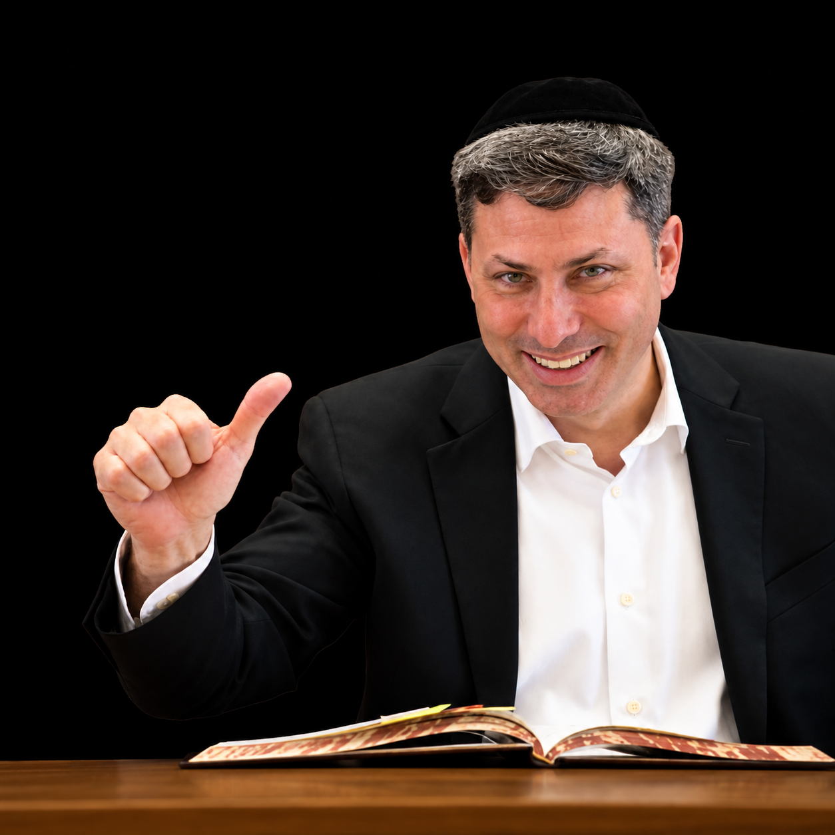

This is Rabbi Eli Stefansky (Mercaz Daf Yomi)

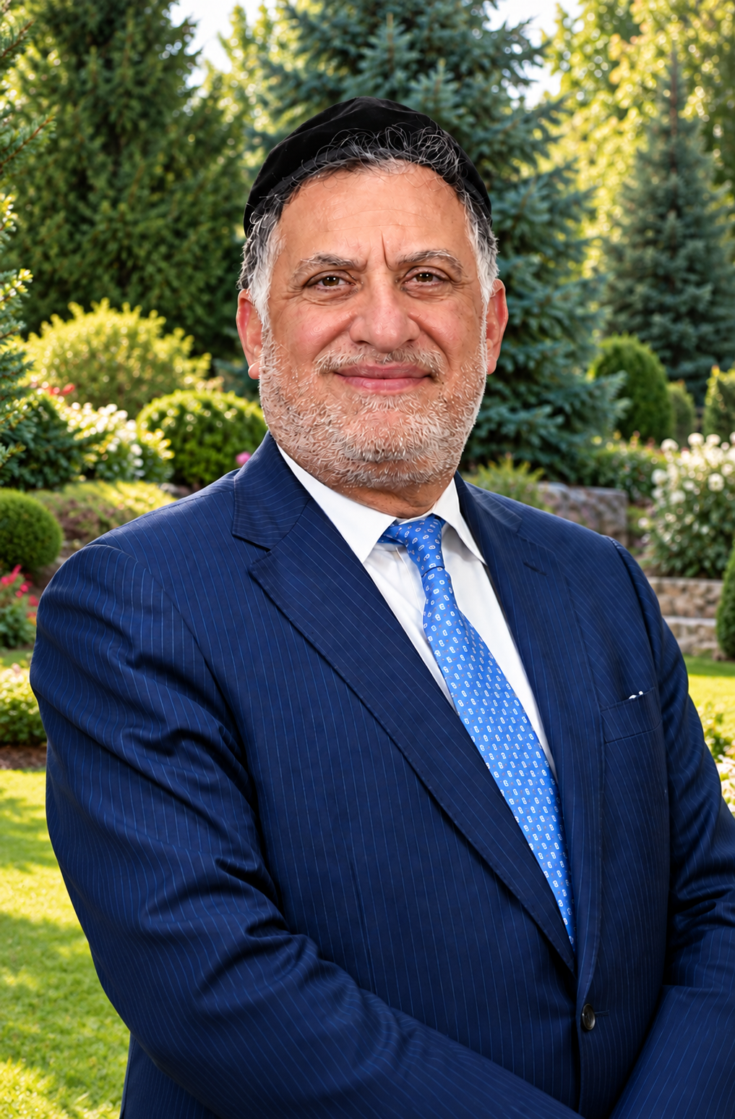
This is Rabbi Eli Mansour

put Alice Rabbi Eli Stefansky (Mercaz Daf Yomi)

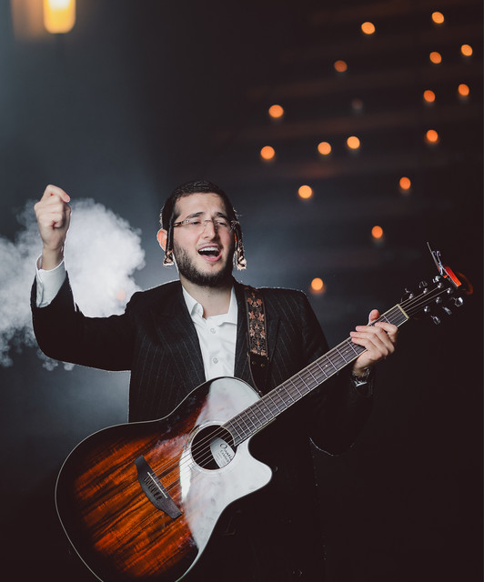
This is Dovi Meisels entertainment number 4

need to add by the world of Astoria and by the Park Hyatt by the dining two extra boxes

New box Grand ballroom

### Grand Ballroom – Yom Tov Dining
Celebrate Yom Tov in the elegant Grand Ballroom, transformed into a beautiful dining setting for our festive holiday meals. Enjoy exceptional gourmet cuisine, attentive service, and a warm, inviting atmosphere as family and friends gather to celebrate together.

Pic for the Grand ballroom

we'll get you a picture tomorrow

New BOX Grand Ballroom – Shabbat & Yom Tov Kiddushim

### Grand Ballroom – Shabbat & Yom Tov Kiddushim
Experience our lavish Shabbat and Yom Tov Kiddushim, featuring an impressive selection of gourmet specialties, traditional favorites, premium wines, and beautifully presented delicacies. A wonderful opportunity to gather, socialize, and celebrate in an elegant and festive atmosphere.

Pic for the Grand ballroom Kiddushim

